1. Task 1: Category Performance Analysis Business Need: Management wants to know which product categories generate the highest revenue. Task: Create a visualization to compare total Sales by Category and identify the top-performing category
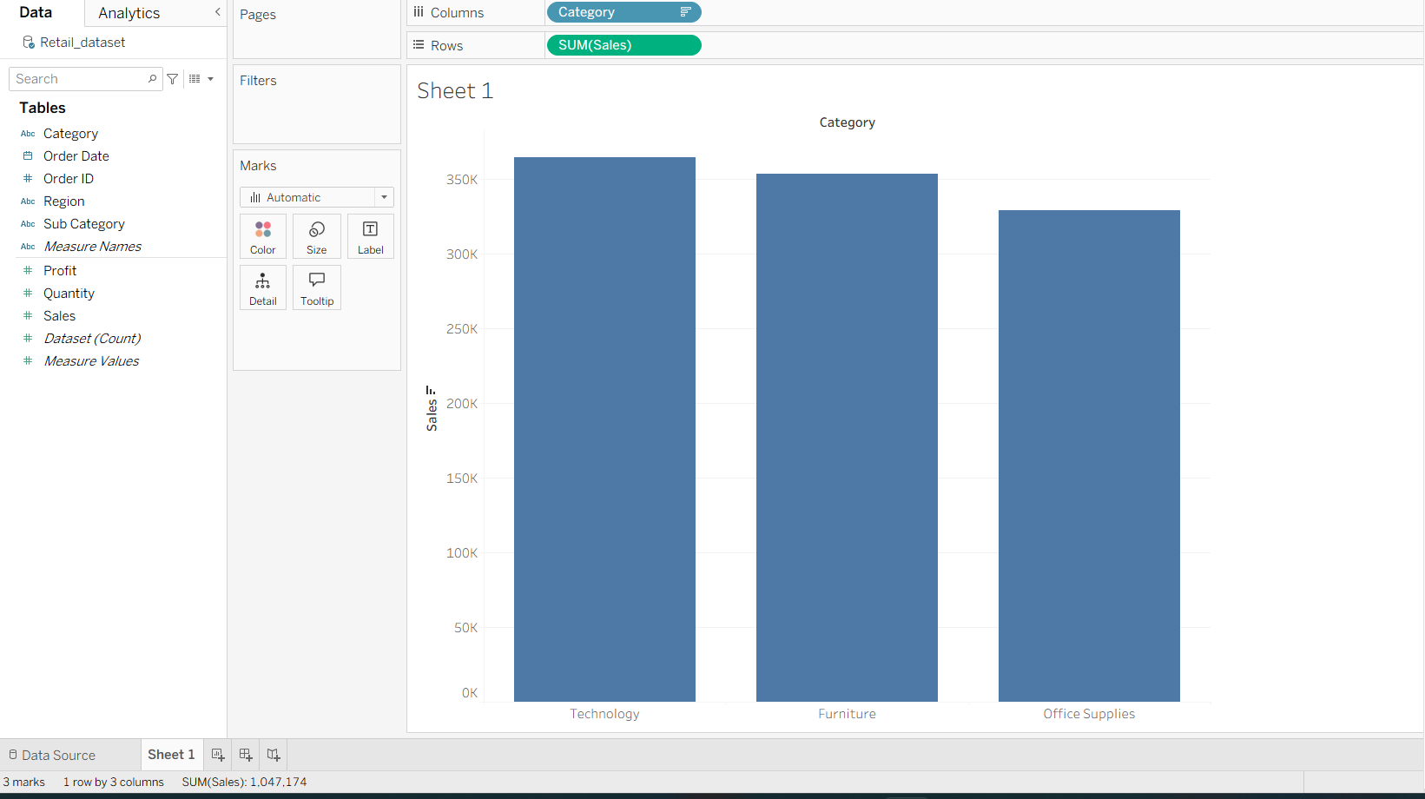

Observation
Compare the total sales of all categories and identify the category with the tallest bar.
Insight
Technology generates the highest revenue among all categories and is the top-performing category.
Business Decision
The company can increase inventory, marketing efforts, and promotional campaigns for Technology products to maximize revenue.

Task 2: Sales Trend Analysis Business Need: The leadership team wants to understand how sales fluctuate over time to plan promotions and inventory. Task: Analyze Sales trends over time (monthly) to identify peak and slow periods

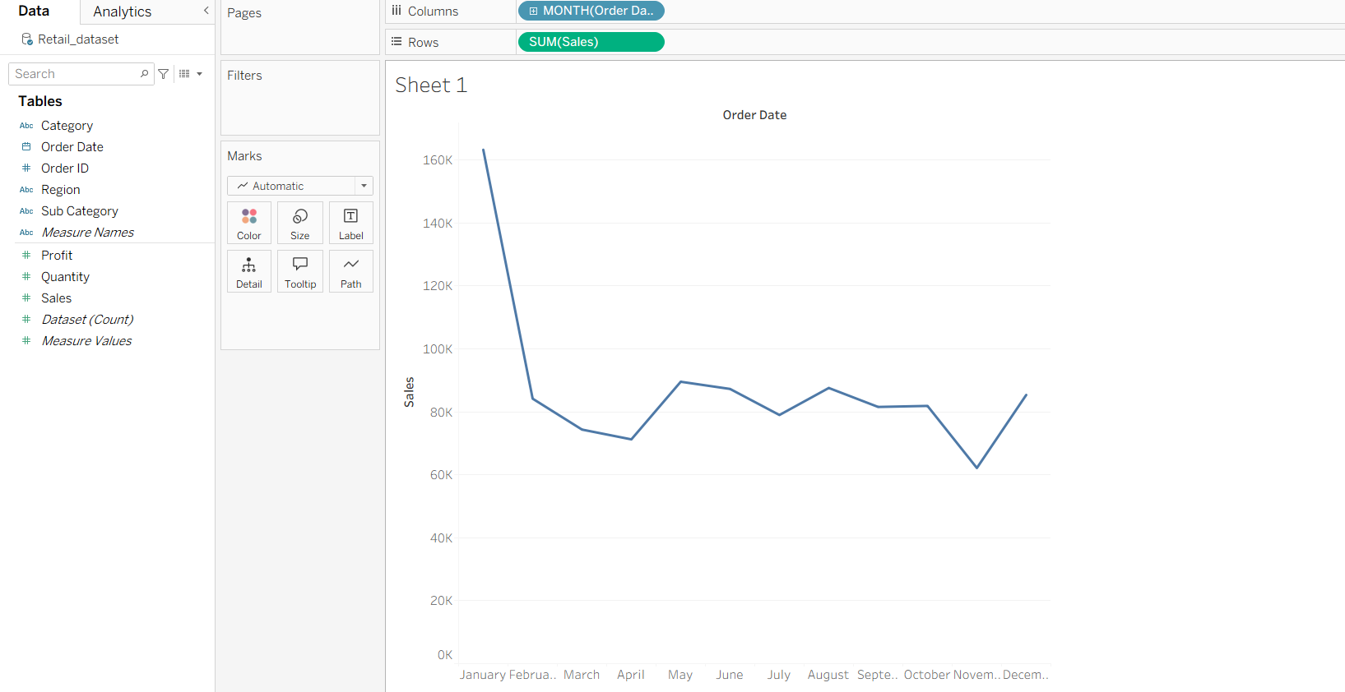
Observation
The line chart shows increases and decreases in sales across different months.
Insight
- Months with the highest points on the line represent peak sales periods.
- Months with lower points indicate slow sales periods.
- Management can identify seasonal trends and demand patterns.
Business Decision
Promotions can be planned during slow months, while inventory can be increased before peak sales periods.

Task 3: Regional Contribution Analysis Business Need: The regional managers want clarity on how much each region contributes to overall sales. Task: Visualize Region-wise Sales contribution and identify the highest contributing region.

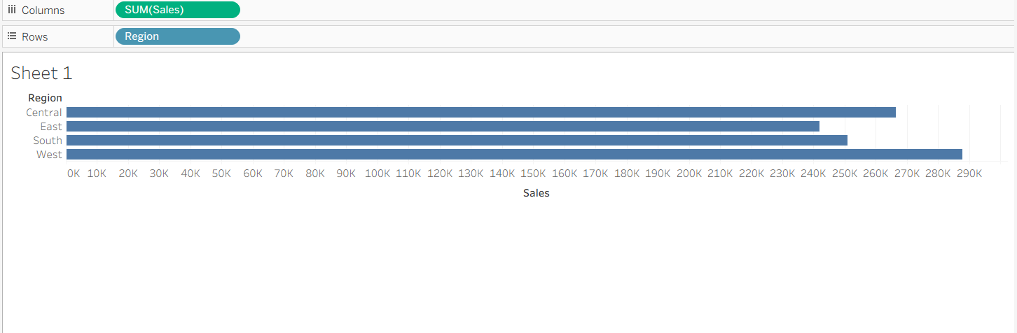
Observation
Compare total sales generated by each region.
Insight
The West Region contributes the highest share of overall sales, followed by the other regions.
Business Decision
Management can study the success factors in the West region and apply similar strategies in lower-performing regions to improve overall performance.

Task 4: Profitability Investigation Business Need: The finance team suspects that some high-sales orders may be reducing overall profit. Task: Analyze the relationship between Sales and Profit to identify loss-making or low-profit orders.

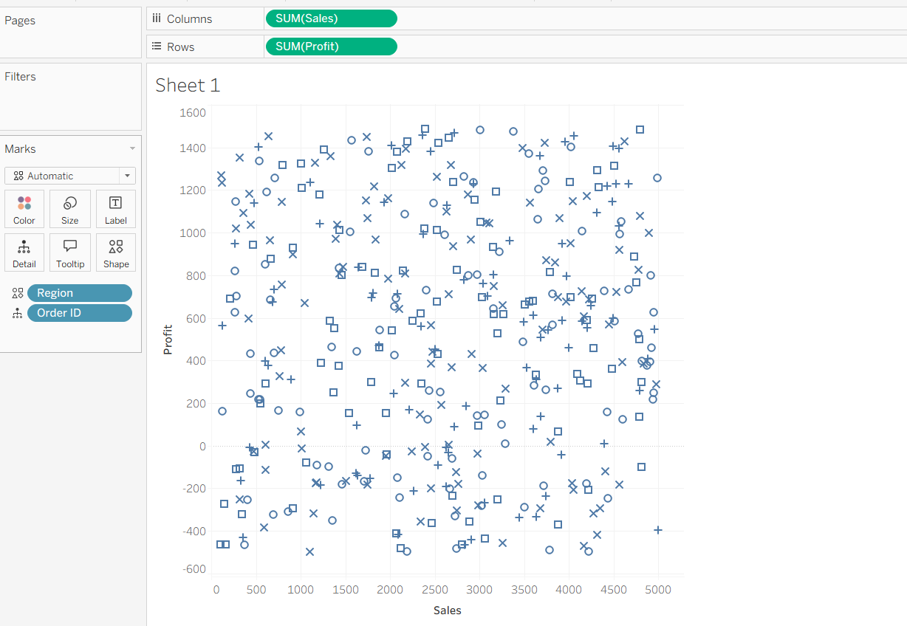
Final Summary
Task | Visualization | Key Finding
Category Performance | Bar Chart | Technology is the highest revenue-generating category
Sales Trend Analysis | Line Chart | Monthly sales reveal peak and slow periods
Regional Contribution | Bar/Pie Chart | West region contributes the highest sales
These visualizations provide actionable insights for sales growth, inventory planning, and regional performance improvement.

Task 5: Business Growth Evaluation Business Need: Senior management wants to assess whether the business is growing consistently. Task: Visualize cumulative Sales growth over time to evaluate overall performance.
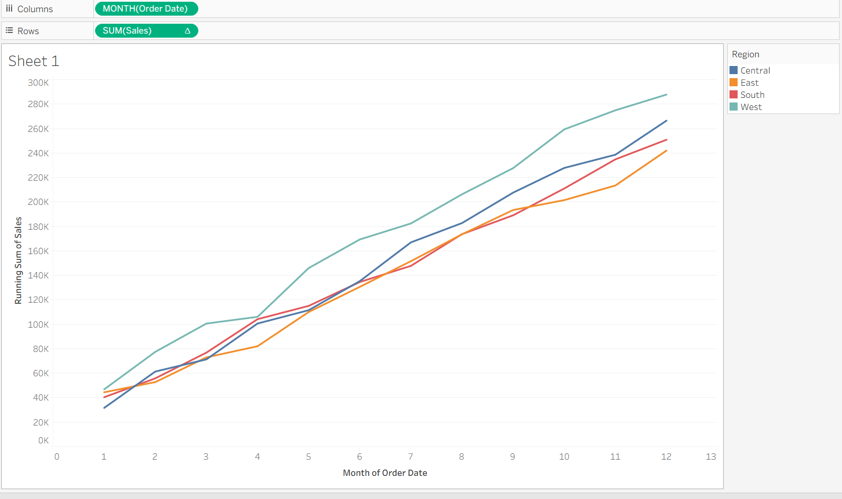

Insight
- Orders in the upper-right quadrant have high sales and high profit.
- Orders in the lower-right quadrant have high sales but low or negative profit.
- These loss-making orders require investigation.
Business Decision
Management can review discount policies, shipping costs, or pricing strategies for low-profit and loss-making orders.

Task 6: Category vs Region Performance Business Need: Operations wants to know which regions perform well for each product category. Task: Compare Category-wise Sales across Regions to identify strong and weak market areas
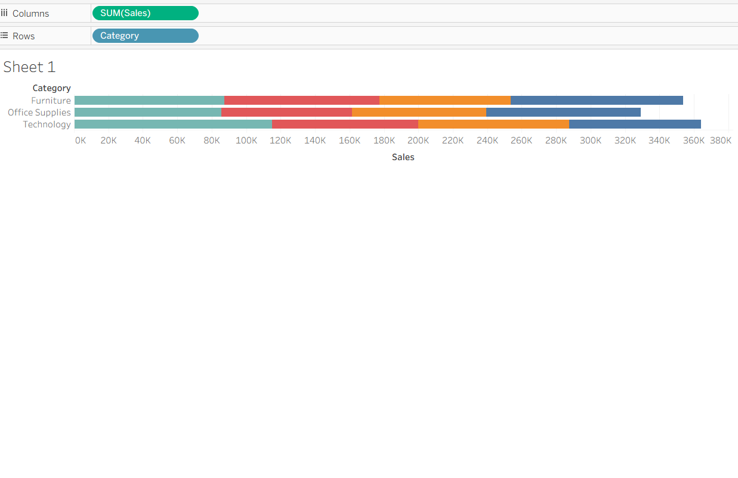
Insight
- Compare regional contribution within each category.
- Identify strong and weak markets for each category.
Business Decision
Allows region-specific marketing and inventory allocation

Task 7: Product Prioritization Business Need:The product team wants to focus on products that create maximum business impact. Task: Perform a multi-dimensional analysis using Sales, Profit, and Quantity to identify priority products.

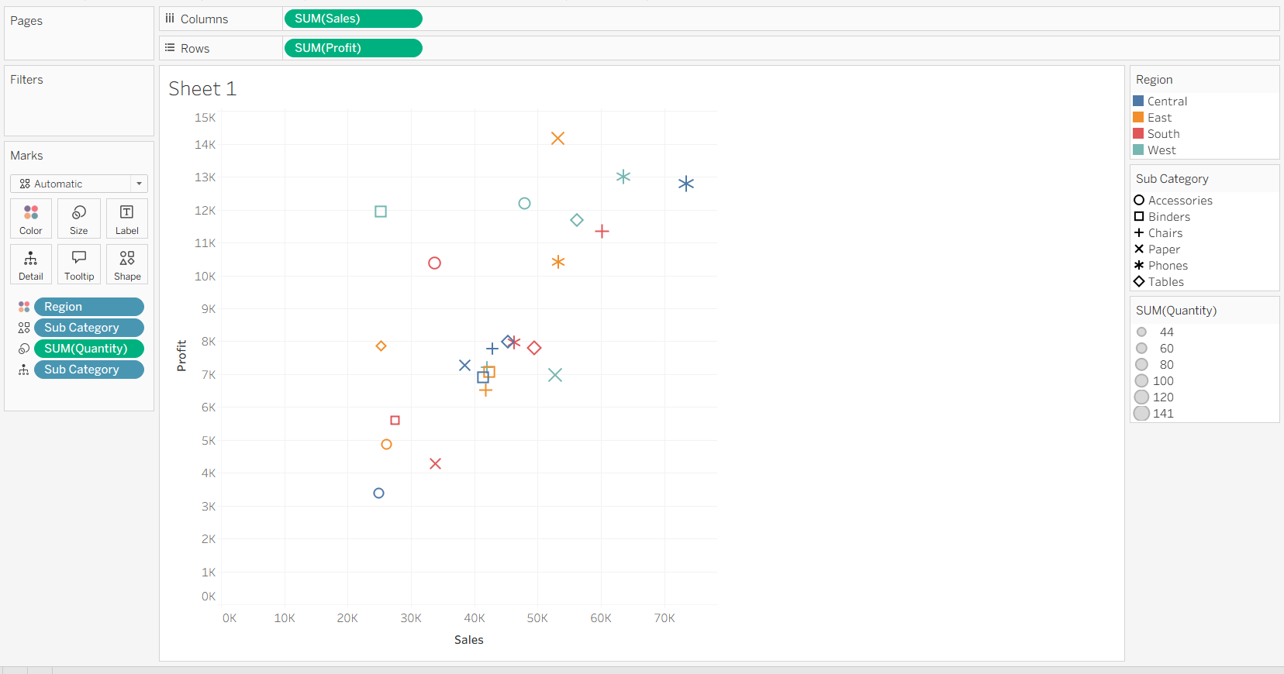

Insight
- Large bubbles with high Sales and Profit are priority products.
- Large bubbles with low Profit need review.
- Small bubbles with low Sales and Profit may require discontinuation.
Business Decision
Focus resources on high-performing products and optimize underperforming ones.

Task 8: Executive Dashboard Creation Business Need: The CEO wants a single view dashboard that summarizes key insights. Task: Create an interactive dashboard combining at least three visualizations and apply filters such as Region or Category.
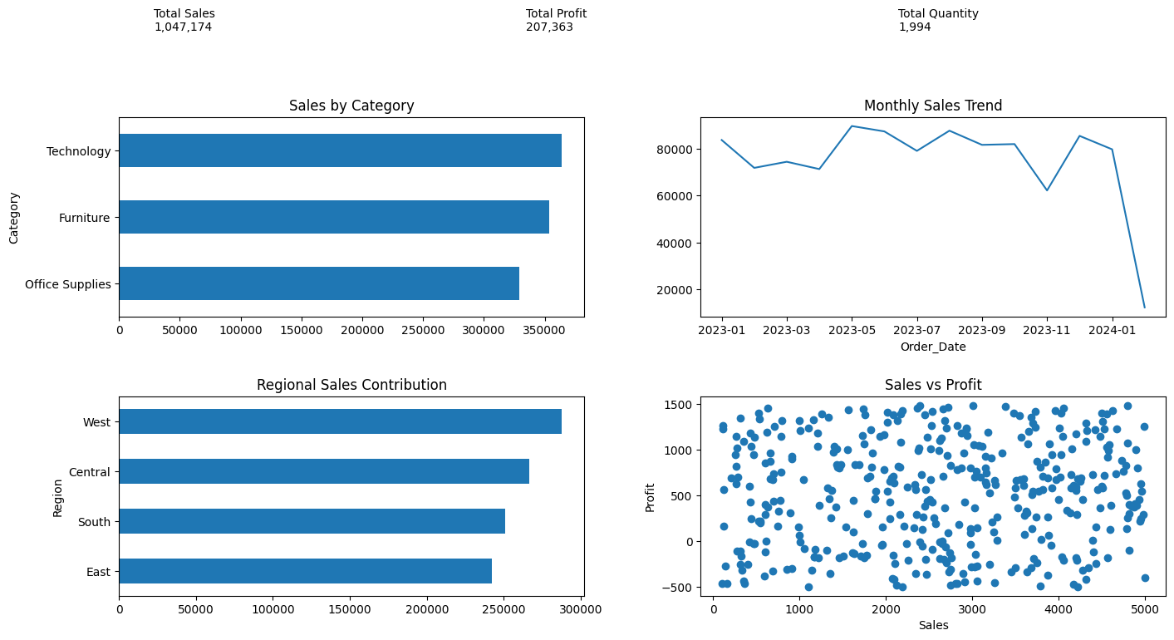

Q9. Chart Selection Justification Explain why different charts were used for different business questions in this analysis.

Business Question | Chart Used | Reason
Category Performance | Bar Chart | Best for comparing values across categories
Sales Trend | Line Chart | Shows changes over time clearly
Regional Contribution | Pie Chart/Bar Chart | Displays contribution of each region
Profitability Investigation | Scatter Plot | Reveals relationship between Sales and Profit
Business Growth | Running Total Line Chart | Shows cumulative growth trend
Category vs Region | Stacked Bar Chart | Compares multiple groups simultaneously
Product Prioritization | Bubble Chart | Displays Sales, Profit, and Quantity together

Different charts are used because each business question requires a different way of presenting and analysing data.

Q10. Business Insight Summary Summarize two key insights from your dashboard and explain how they can help management make better decisions.

Insight 1: Technology Category Generates the Highest Sales
The Technology category contributes the largest share of revenue.
Management Benefit:
- Increase inventory levels.
- Invest more in marketing and promotions.
- Expand product offerings within this category.

Insight 2: West Region Delivers the Strongest Performance
The West region contributes the highest sales and profit compared to other regions.
Management Benefit:
- Study successful strategies used in the West.
- Replicate those practices in lower-performing regions.
- Allocate resources more effectively to maximize growth.
Conclusion
The dashboard helps management identify profitable categories, monitor business growth, evaluate regional performance, and make data-driven decisions that improve overall business performance.

